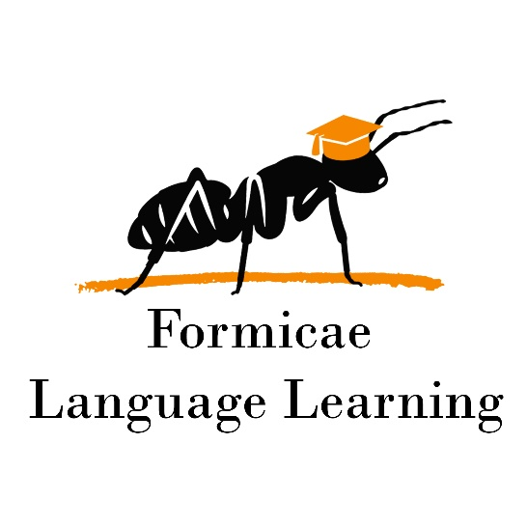

Beginner Syntax Course syllabus

**Duration:** 15 weeks

**Course Description**:

This course provides a comprehensive introduction to syntax and grammar, focusing on the forms and functions of words, phrases, and clauses. Students will learn to analyze sentence structures, identify grammatical roles (e.g., subjects, predicates, objects, and complements), and understand how modifiers function within sentences. The course combines theoretical explanations with practical exercises to reinforce learning.

**Homework:** 2 types of homework exercises are scheduled each week. In addition, a test follows each unit. The homework and the tests are mandatory and count towards participation. These must be submitted within 5 days after the class.

**Pace:** 1, 90-minute class per week

**Week 1: Introduction to Syntax and Grammar**

* **Topics:**
  + What is syntax?
  + Overview of grammatical forms and functions.
  + Parts of speech: Nouns, verbs, adjectives, adverbs, prepositions, conjunctions, and interjections.
* **Homework:**
  + Identify parts of speech in 10 sentences.
  + Write 5 sentences using each part of speech.

**Week 2: Word Forms and Their Functions**

* **Topics:**
  + Inflectional vs. derivational morphology.
  + Word classes and their syntactic roles.
  + Functions of nouns (subjects, objects, complements) and verbs (predicates).
* **Homework:**
  + Analyze 10 sentences to identify the function of nouns and verbs.
  + Create 5 sentences with specific word forms and label their functions.

**Week 3: Phrases and Their Structures**

* **Topics:**
  + Noun phrases, verb phrases, prepositional phrases, adjective phrases, and adverb phrases.
  + Heads, modifiers, and complements in phrases.
* **Homework:**
  + Identify and label phrases in 10 sentences.
  + Write 5 sentences with different types of phrases.

**Week 4: Grammatical Roles in Sentences**

* **Topics:**
  + Subjects and predicates.
  + Direct and indirect objects.
  + Subject complements and object complements.
* **Homework:**
  + Analyze 10 sentences to identify subjects, predicates, objects, and complements.
  + Write 5 sentences with complements and label their roles.

**Week 5: Modifiers and Their Functions**

* **Topics:**
  + Adjectives and adverbs as modifiers.
  + Prepositional phrases as modifiers.
  + Restrictive vs. non-restrictive modifiers.
* **Homework:**
  + Identify modifiers in 10 sentences and explain their functions.
  + Write 5 sentences with restrictive and non-restrictive modifiers.

**Week 6: Review of WORD FORMS, PHRASES, and FUNCTIONS**

* **Homework:**
  + Identify each word form and function of the 10 sentences.
  + Write 5 sentences and show each form and function.

**Week 7: Introduction to Clauses**

* **Topics:**
  + Independent vs. dependent clauses.
  + Finite vs. non-finite clauses.
  + Functions of clauses in sentences.
* **Homework:**
  + Identify independent and dependent clauses in 10 sentences.
  + Write 5 sentences with both types of clauses.

**Week 8: Relative Clauses**

* **Topics:**
  + Structure and function of relative clauses.
  + Relative pronouns (who, whom, whose, which, that).
  + Restrictive vs. non-restrictive relative clauses.
* **Homework:**
  + Identify relative clauses in 10 sentences.
  + Write 5 sentences using relative clauses.

**Week 9: Adverbial Clauses**

* **Topics:**
  + Functions of adverbial clauses (time, place, condition, reason, purpose, etc.).
  + Subordinating conjunctions (because, although, if, when, etc.).
* **Homework:**
  + Identify adverbial clauses in 10 sentences.
  + Write 5 sentences using adverbial clauses.

**Week 10: Noun Clauses**

* **Topics:**
  + Functions of noun clauses (subjects, objects, complements).
  + Subordinating conjunctions in noun clauses (that, whether, if, etc.).
* **Homework:**
  + Identify noun clauses in 10 sentences.
  + Write 5 sentences using noun clauses.

**Week 11: REVIEW OF CLAUSES**

* **Homework:**
  + Identify types of clauses in 10 sentences.
  + Write 5 sentences and label the relative, adverbial, and noun clauses.

**Week 12: Sentence Types and Structures**

* **Topics:**
  + Simple, compound, complex, and compound-complex sentences.
  + Coordination and subordination.
* **Homework:**
  + Identify sentence types in 10 examples.
  + Write 5 sentences of each type.

**Week 13: Syntactic Ambiguity and Sentence Analysis**

* **Topics:**
  + Causes of syntactic ambiguity.
  + Techniques for analyzing complex sentences.
* **Homework:**
  + Analyze 5 ambiguous sentences and explain their possible interpretations.
  + Write 5 sentences with intentional ambiguity.

**Week 14: Sentence Analysis II**

* **Topics:**
  + Overview of words, phrases and clauses and their functions in sentences
  + Q&A session.
* **Homework:**
  + Write 10 sentences featuring the use of dependent clauses.
  + Identify and label word forms, phrases, clauses, and their functions.

**Week 15: Review and Final Project**

* **Topics:**
  + Review of all topics covered in the course.
  + Q&A session.
* **Final Project:**
  + Write a short essay (1-2 pages) analyzing the syntax of a chosen text (e.g., a poem, news article, or excerpt from a book).
  + Identify and label word forms, phrases, clauses, and their functions.