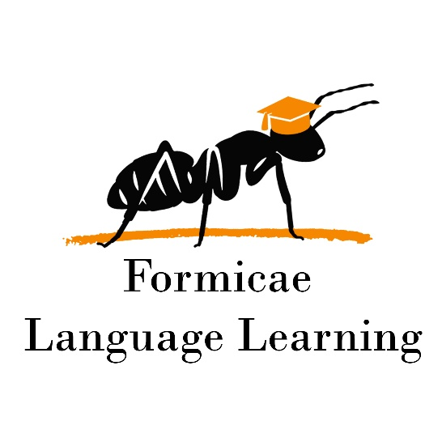

Unlock L1 course syllabus

**Duration:** 24 weeks

**Goal:** The Unlock L1/L2 courses are primarily aimed at expanding world knowledge and communication abilities of students. Though some grammar is involved, the course itself doesn’t prioritize it. Listening comprehension, reading comprehension, vocabulary expansion, oral skills, and writing skills are heavily covered. The course features the use of 2 accompanying books, Unlock Listening and Speaking and Unlock Reading and Writing. Appropriate homework is scheduled by the teacher. Each unit features a mandatory listening comprehension homework. Other exercises are scheduled as homework as the course progresses. This is based on the pace of the group and is left to the teacher’s discretion. Namely, if the group advances at a good pace, fewer additional homework exercises are needed.

**Pace:** 2, 50-minute classes per week

**Classes 1,2,3 – Unit 1 R&W – People**

Skills: Previewing a text

Grammar: Subject Pronouns, Verb TO BE, Possessive adjectives

**Classes 4,5,6 – Unit 1 L&S – People**

Skills: Understanding key vocabulary

Grammar: Subject Pronouns and Possessive adjectives

**Classes 7,8,9 – Unit 2 R&W – Seasons**

Skills: Scanning to find information

Grammar: Nouns and Adjectives, Noun Phrases

**Classes 10,11,12 – Unit 2 L&S – Seasons**

Skills: Predicting content using visuals  
Grammar: There is / There are

**Classes 13,14,15 – Unit 3 R&W – Lifestyle**

Skills: Annotating a text

Grammar: Parts of a sentence, The present simple tense

**Classes 16,17,18 – Unit 3 L&S – Lifestyle**

Skills: Listening for main ideas

Grammar: Statements and Questions in the Present Simple Tense

**Classes 19,20,21 – Unit 4 R&W – Places**

Skills: Reading for main ideas

Grammar: Noun phrases with of, There is / There are, Articles

**Classes 22,23,24 – Unit 4 L&S – Places**

Skills: Listening for detail

Grammar: Prepositions of place, the imperative

**Classes 25, 26, 27 – Unit 5 R&W – Jobs**

Skills: Reading for detail, Synthesizing

Grammar: adjective phrases, must and have to

**Classes 28,29,30 – Unit 5 L&S – Jobs**

Skills: Predicting content

Grammar: Have to, has to, should, comparative adjectives

**Classes 31,32,33 – Unit 6 R&W – Homes and Buildings**

Skills: Predicting content using visuals

Grammar: Adjectives, comparing quantities, comparative adjectives

**Classes 34,35,36 – Unit 6 L&S – Homes and Buildings**

Skills: Listening for reasons

Grammar: Giving opinions with should

**Classes 37,38,39 – Unit 7 R&W – Food and Culture**

Skills: Skimming, Taking notes

Grammar: Countable and uncountable nouns, the verb can, determiners

**Classes 40, 41, 42 – Unit 7 L&S – Food and Culture**

Skills: Listening for numbers

Grammar: The past simple tense, Statements, Irregular verbs

**Classes 43,44,45 – Unit 8 R&W – Transport**

Skills: Working out meaning from context

Grammar: Superlative adjectives, quantifiers, Linking sentences with pronouns

**Classes 46,47,48 – Unit 8 L&S – Transport**

Skills: Listening for definitions, synthesizing information

Grammar: The past simple tense, more irregular verbs