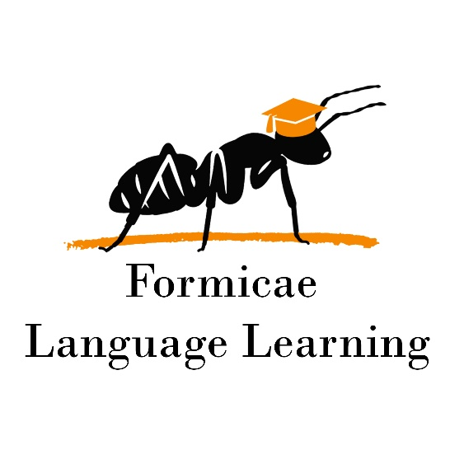

Wonders G1 course syllabus

**Duration:** 30 weeks

**Goal:** General language course meant to familiarize students with basic grammar concepts. Accompanied by level and age-appropriate reading and vocabulary. All skills are worked on simultaneously. Homework is scheduled each week. Three accompanying homework books are used (Grammar, Phonics, and Your Turn)

**Pace:** 2, 50-minute classes per week

WEEK / HOMEWORK / MAIN GRAMMAR TOPIC

Week 1 – G1U1W1 – Sentences, sentence types

Week 2 – G1U1W2 – Word Order

Week 3 – G1U1W3 – Statement

Week 4 – G1U1W4 – Questions and Exclamations

Week 5 – G1U1W5 – Writing Sentences

Week 6 – G1U2W1 – Word forms, Nouns

Week 7 – G1U2W2 – Singular and Plural

Week 8 – G1U2W3 – Possessive Nouns

Week 9 – G1U2W4 – Common and Proper Nouns

Week 10 – G1U2W5 – Irregular Plural

Week 11 – G1U3W1 – Word forms, Verbs

Week 12 – G1U3W2 – Present Simple Tense

Week 13 – G1U3W3 – Past Simple tense / Future Simple tense

Week 14 – G1U3W4 – Irregular verbs (TO BE)

Week 15 – G1U3W5 – Contractions with NOT

Week 16 – G1U4W1 – Was and Were

Week 17 – G1U4W2 – Has and Have

Week 18 – G1U4W3 – Go and Do

Week 19 – G1U4W4 – See and Saw

Week 20 – G1U4W5 – Adverbs of Time

Week 21 – G1U5W1 – Conjunctions

Week 22 – G1U5W2 – Adjectives

Week 23 – G1U5W3 – Comparison of Adjectives  
Week 24 – G1U5W4 – Special Adjectives

Week 25 – G1U5W5 – Prepositions

Week 26 – G1U6W1 – Pronouns  
Week 27 – G1U6W2 – Possessive Pronouns

Week 28 – G1U6W3 – Indefinite Pronouns

Week 29 – G1U6W4 – Using I and Me

Week 30 – G1U6W5 – Adverbs of Manner