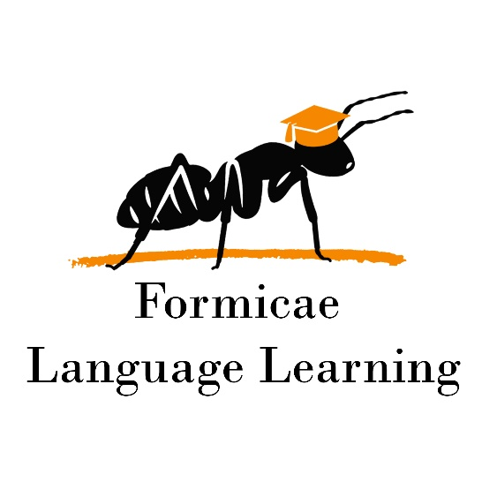

Wonders G2 course syllabus

**Duration:** 30 weeks

**Goal:** General language course meant to familiarize students with basic grammar concepts. Accompanied by level and age-appropriate reading and vocabulary. All skills are worked on simultaneously. Homework is scheduled each week. Three accompanying homework books are used (Grammar, Phonics, and Your Turn)

**Pace:** 2, 50-minute classes per week

WEEK / HOMEWORK / MAIN GRAMMAR TOPIC

Week 1 – G2U1W1 – Sentences, sentence types

Week 2 – G2U1W2 – Commands, Exclamations

Week 3 – G2U1W3 – Basic Functions, Subject

Week 4 – G2U1W4 – Predicates

Week 5 – G2U1W5 – Expanding and Combining Sentences

Week 6 – G2U2W1 – Word forms, Nouns

Week 7 – G2U2W2 – Singular and Plural

Week 8 – G2U2W3 – Noun Types

Week 9 – G2U2W4 – Special Plurals of Nouns

Week 10 – G2U2W5 – Possessive Nouns

Week 11 – G2U3W1 – Word forms, Verbs

Week 12 – G2U3W2 – Present Simple Tense

Week 13 – G2U3W3 – Past Simple tense

Week 14 – G2U3W4 – Irregular verbs (have)

Week 15 – G2U3W5 – Rearranging Sentences

Week 16 – G2U4W1 – Linking Verbs

Week 17 – G2U4W2 – Helping Verbs

Week 18 – G2U4W3 – Irregular verbs (do, go)

Week 19 – G2U4W4 – Irregular verbs (come, run, hide)

Week 20 – G2U4W5 – Contractions

Week 21 – G2U5W1 – Pronouns

Week 22 – G2U5W2 – Pronoun types (object pronouns)

Week 23 – G2U5W3 – Pronoun types (possessive pronouns)  
Week 24 – G2U5W4 – Contractions (w/ pronouns)

Week 25 – G2U5W5 – Pronoun-Verb agreement

Week 26 – G2U6W1 – Adjectives (possessive)  
Week 27 – G2U6W2 – Articles and special pronouns

Week 28 – G2U6W3 – Comparison of adjectives

Week 29 – G2U6W4 – Adverbs and Prepositional Phrases

Week 30 – G2U6W5 – Adjectives / Adverbs – contrasting